**Name: Iyer Krithika Ganesh Sundaram**

**UNID: u1135255**

**Email ID: u1135255@utah.edu**

# **Project 3**

1. **Image warping(Morphing)**

As described in the requirements, a program to perform morphing of two images using radial basis functions has been implemented. The inputs to the function:

* Parameter file

This text file which contains all the details required for the transformation. The details include.

-Number of control points =2M

-Number of input images =N

-The control point array

-The name of the input images

-The name of the output image

-The number of intermediate images

-The kernel width for gaussian kernel

The algorithm for morphing of the given images is as follows.

1. Parameter file is read and the values mentioned under parameter file are extracted.
2. Using the correspondence points from image 1(X, Y) and image 2(XPrime, YPrime) the value of C(t) is calculated for one value of t using the formula

CX=(1-t) \* X + t \* XPrime

CY=(1-t) \* Y + t \* YPrime

Here t goes from 0 to 1and t depends on the number of intermediate images t = 1/ (number of images +1) and it is changed at each iteration to get intermediate images. For value of t=0 the transformation leads to image 1 and for t=1 it leads to image 2.

1. The RBF values for the forward transformation from (X, Y) to (CX, CY) and (XPrime, YPrime) to (CX, CY) are calculated
2. The RBF values are applied to the two images and the two-intermediate image pixel location values are calculated
3. Using the intermediate images, the maximum and minimum pixel locations are found and the offset and the size of the canvas are decided
4. The backward transformation is performed to find out the intensity of the pixel locations found in the forward transformation.
5. So, RBF values for (CX, CY) to (X, Y) and (CX, CY) to (XPrime, YPrime) are found.
6. The RBF values are applied to the intermediate image and the pixel locations are found. These locations are checked if they lie in the image 1 and image 2.
7. If they lie within the bounds of image 1 and image 2, they intensity values are interpolated using bilinear interpolation.
8. The two images obtained after reverse transformation are combined using the formula

OutPut = (1-t) \* OutPut1 + t \* OutPut2

This gives us the morphing of the two images.

1. Whole processed is repeated for values of t ranging from 0 to 1.
2. Before applying the transformation, the histogram of the two images is equalized.
3. For the calculation of RBF there two options of kernels:  
   -Thin Plate Spline

-Gaussian

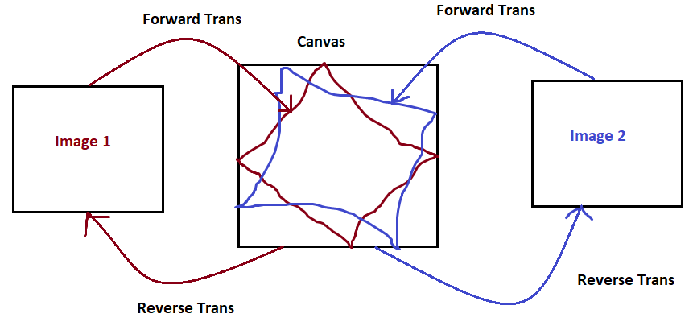

Example: 1 Using Thin Plate Spline

 

Image 1 Image 2

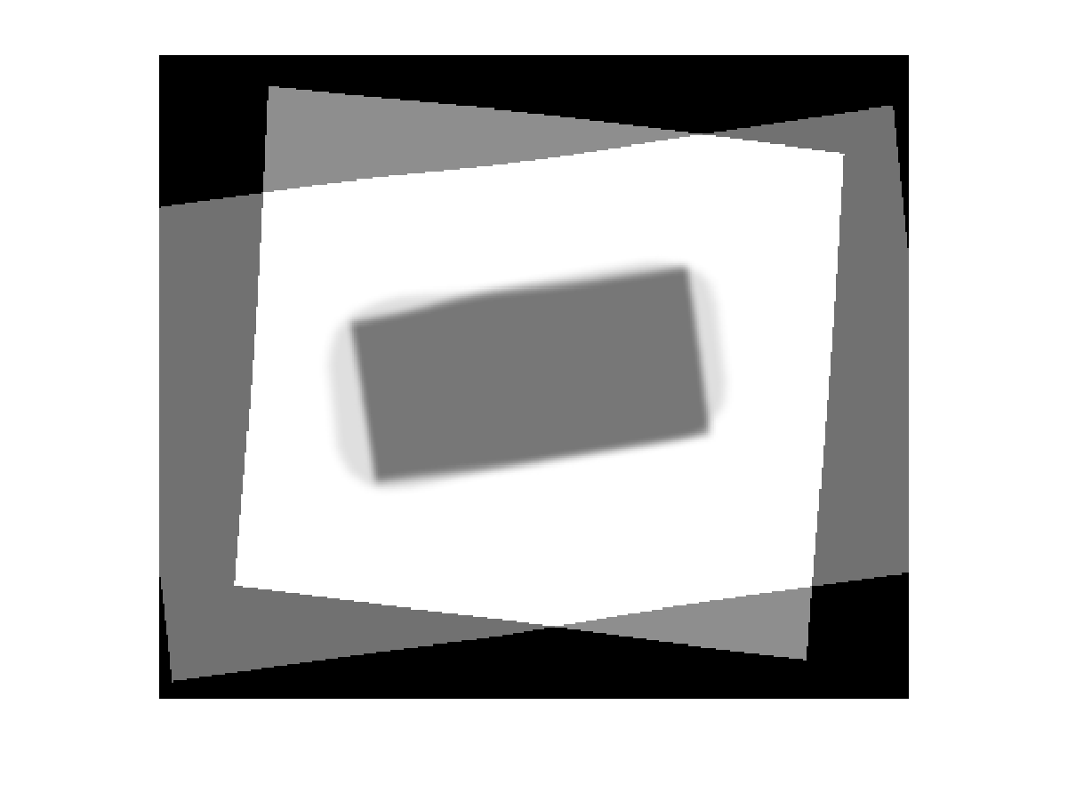

Morphed Image at t=0.55

Example: 2

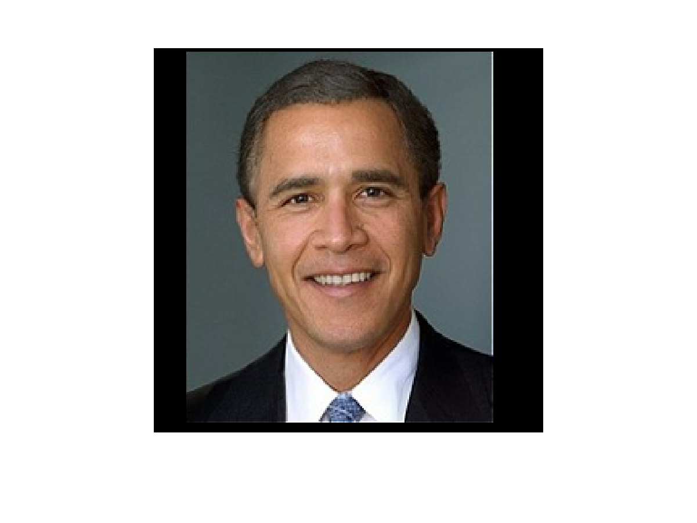 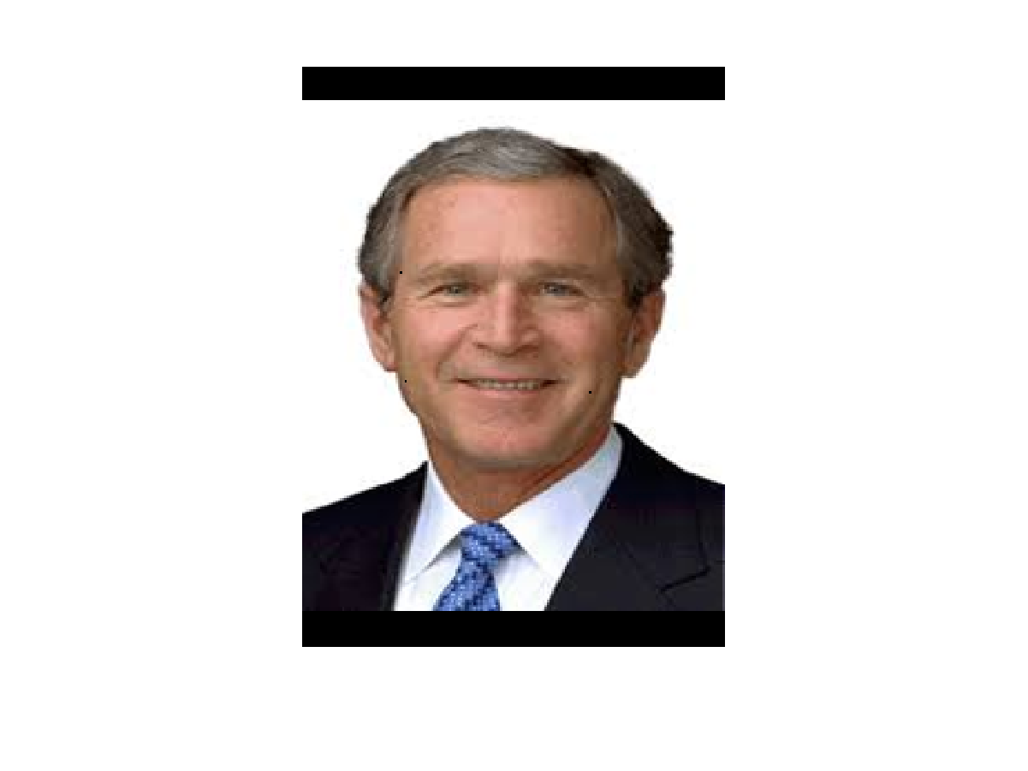  
 Image 1 Image 2

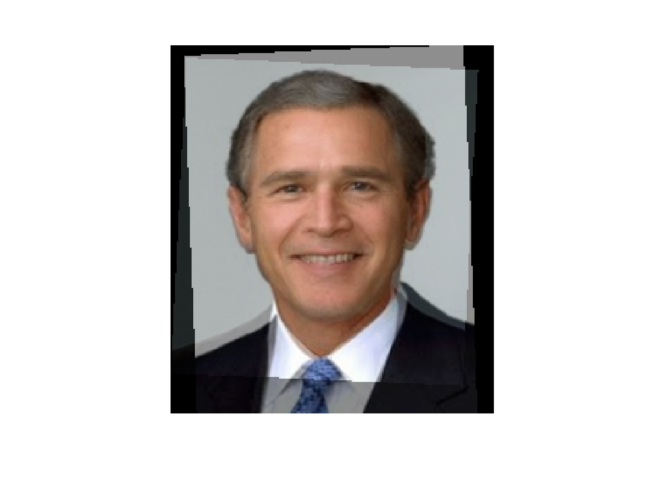Using Thin Plate Spline Using Gaussian Kernel  
Morphed Image at t=0.55

Input Images

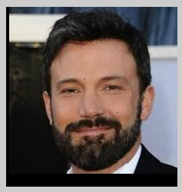 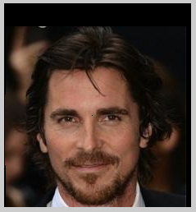

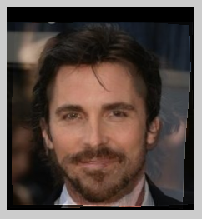 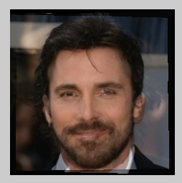

Morph at t=0.55 with spline and gaussian

***CODE: morphing.m , rbf\_cal.m, forward.m , reverse.m , bilinear.m***

1. **Image Atlas creation.**

As described in the requirements, a program to perform morphing of two images using radial basis functions has been implemented. The inputs to the function:

* Parameter file

This text file which contains all the details required for the transformation. The details include.

-Number of control points =2M

-Number of input images =N

-The control point array

-The name of the input images

-The name of the output image

-The number of intermediate images

-The kernel width for gaussian kernel

The algorithm for morphing of the given images is as follows:

1. The parameter file is read and the values mentioned in the parameter file are extracted.
2. Using the M correspondence points from the N images the value of landmark CX, CY are calculated as follows:

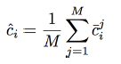

1. The RBF values for the forward transformation from (Xi, Yi) to (CX, CY) and are calculated.
2. The RBFs corresponding the image are applied and intermediate pixel locations are found.
3. The maximum and minimum values of the pixel location is found from each intermediate image and a global size of the intermediate image is found ie canvasX and canvasY.
4. The backward transformation is performed to find out the intensity of the pixel locations found in the forward transformation.
5. So, RBF values for (CX, CY) to (Xi, Yi) (i=1 to N) are found.
6. The RBF values are applied to the intermediate image and the pixel locations are found. These locations are checked if they lie within the corresponding images and their value is interpolated using bilinear interpolation.
7. For the calculation of RBF there two options of kernels:  
   -Thin Plate Spline

-Gaussian

Example  
 Using Thin Plate Spline Using Gaussian & Histeq

C:\Users\hp-pc\AppData\Local\Microsoft\Windows\INetCache\Content.Word\atlas_out.tif***C:\Users\hp-pc\AppData\Local\Microsoft\Windows\INetCache\Content.Word\atlas_out.tif***

Atlas

Sizing and Histogram: Since forward transform is being done to find out the canvas size even if the image sizes are different the morphing is done seamlessly. For histogram equalization histeq (inbuilt function) is used. This is done for both morphing and atlas creation.

Input Images

C:\Users\hp-pc\AppData\Local\Microsoft\Windows\INetCache\Content.Word\shape_atlas1.tif C:\Users\hp-pc\AppData\Local\Microsoft\Windows\INetCache\Content.Word\shape_atlas2.tif

Image 1 Image 2

C:\Users\hp-pc\AppData\Local\Microsoft\Windows\INetCache\Content.Word\shape_atlas4.tif C:\Users\hp-pc\AppData\Local\Microsoft\Windows\INetCache\Content.Word\shape_atlas3.tif

Image 3 Image 4

***CODE: atlasofimages.m , rbf\_cal.m, forward.m , reverse.m , bilinear.m***

Example 3 : Atlas of car images

C:\Users\hp-pc\AppData\Local\Microsoft\Windows\INetCache\Content.Word\caratlas_out.tif  
Atlas with Thine plate spline  
C:\Users\hp-pc\AppData\Local\Microsoft\Windows\INetCache\Content.Word\caratlas_out.tif  
Atlas with Gaussian

Input images:  
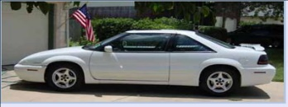 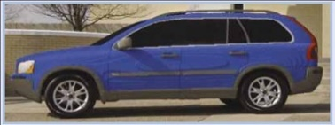 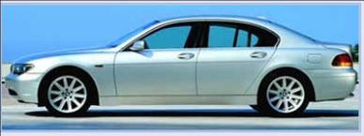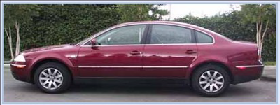 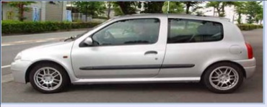 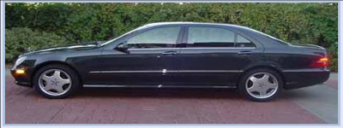

Example 3 : Atlas of brain images & with histeq

C:\Users\hp-pc\AppData\Local\Microsoft\Windows\INetCache\Content.Word\brain_out.tif

1. **Questions**
2. How is the quality of the morph or atlas (shape, intensity) affected by the number of control points?   
   **Answer:** The number of control points decide how well we can morph two images or in case of atlas how well the temple is formed. The more number of precise control points we have the better morphing/atlas we get. Also, the position of the control points is also important. For shapes it is necessary to have control points at the corners. For human images, eyes and mouth need to have enough control points to result in seamless morphing.  
     
    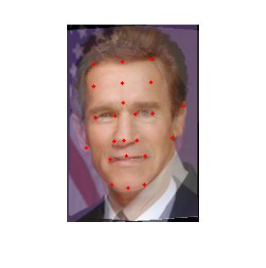  
    Example of control points for human face morphing  
     
   Morphing Results with less control points:

With 10 control points With 3 control points   
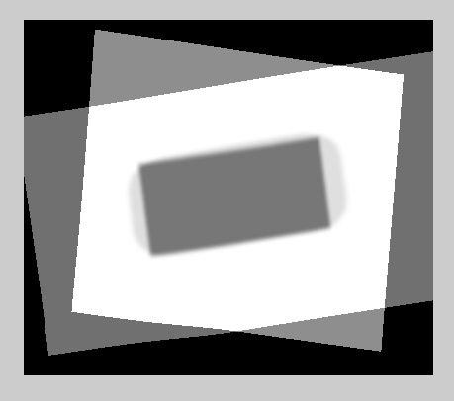 

Atlas results with less control points:

With 8 control points With 3 control points.

C:\Users\hp-pc\AppData\Local\Microsoft\Windows\INetCache\Content.Word\atlas_out.tif 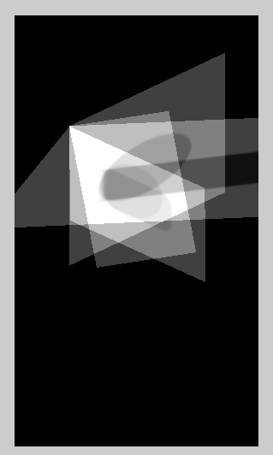

1. How is the quality of the morph or atlas (shape, intensity) affected by the choice of radial basis functions and parameters?   
   **Answer:** The radial basis function effect the quality of the morph greatly. When using the gaussian kernel it was found that they have very sensitive parameters and the value of sigma (kernel width) greatly affects the output. With very high or extremely low value of sigma the optimum morphing or atlas is not obtained. Thin plate spline always showed better results are compared to Gaussian kernel and also thin plate spline is also more robust and is not effected by another parameter other than the distance between the control points where as gaussian greatly depends on the sigma (kernel width).
2. For the atlas example, what kinds points are easily found among the different brain images?   
   **Answer:** This image shows the landmark points which are obtained easily. The points are basically present at the edges of the shapes and patterns seen in the brain image

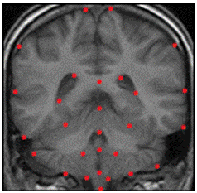

Some of the control points are: (Brian Inferior view)

* Medulla oblongata
* Uncus
* Optic Chaisam
* Olfactory Bulb

1. From your experiments how does the accuracy of the control points affect the results  
   **Answer:** The accuracy of the control points is very important for morphing and atlas creation.

Following are the bad example where the control points were incorrect and hence the results are extremely distorted.  
 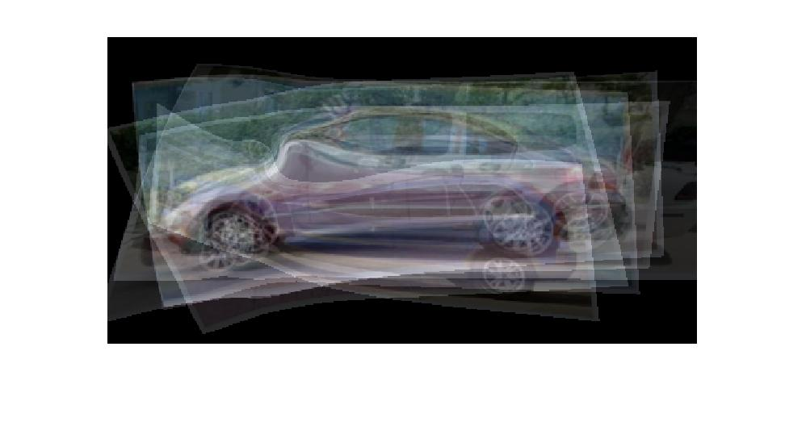

Results of wrong control points for atlas.

In case of atlas the CX’s and CY’s are formed by taking the average of the control points. Here even if a single point is wrong the average would be affected and the template produced could have unnecessary artifacts.

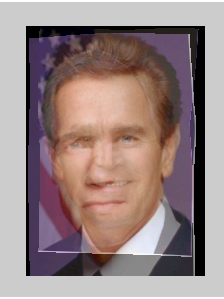 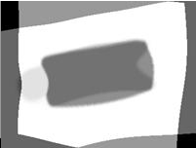   
Incorrect control points in case of morphing t=0.5

As the value of the values of the kernels (gaussian/thin plate) depend upon the distance between the control points of the image, it is extremely essential to take correct points. Each point contributes equally in the formation of the matrix of phi(x). Hence, even a small change in the control points results in distorted morphing. Morphing is not seamless if the points are wrong.